WEB PROGRAMMING

MINI PROJECT

REVIEW 2

NAME- ABHIRUP BANIK
REGISTRATION NUMBER- 24BCE0311

SLOT- L9+L10+L23+L24 | TAA2

FACULTY- DR. JAYAKUMAR K
HOME PAGE



REGISTRATION PAGE

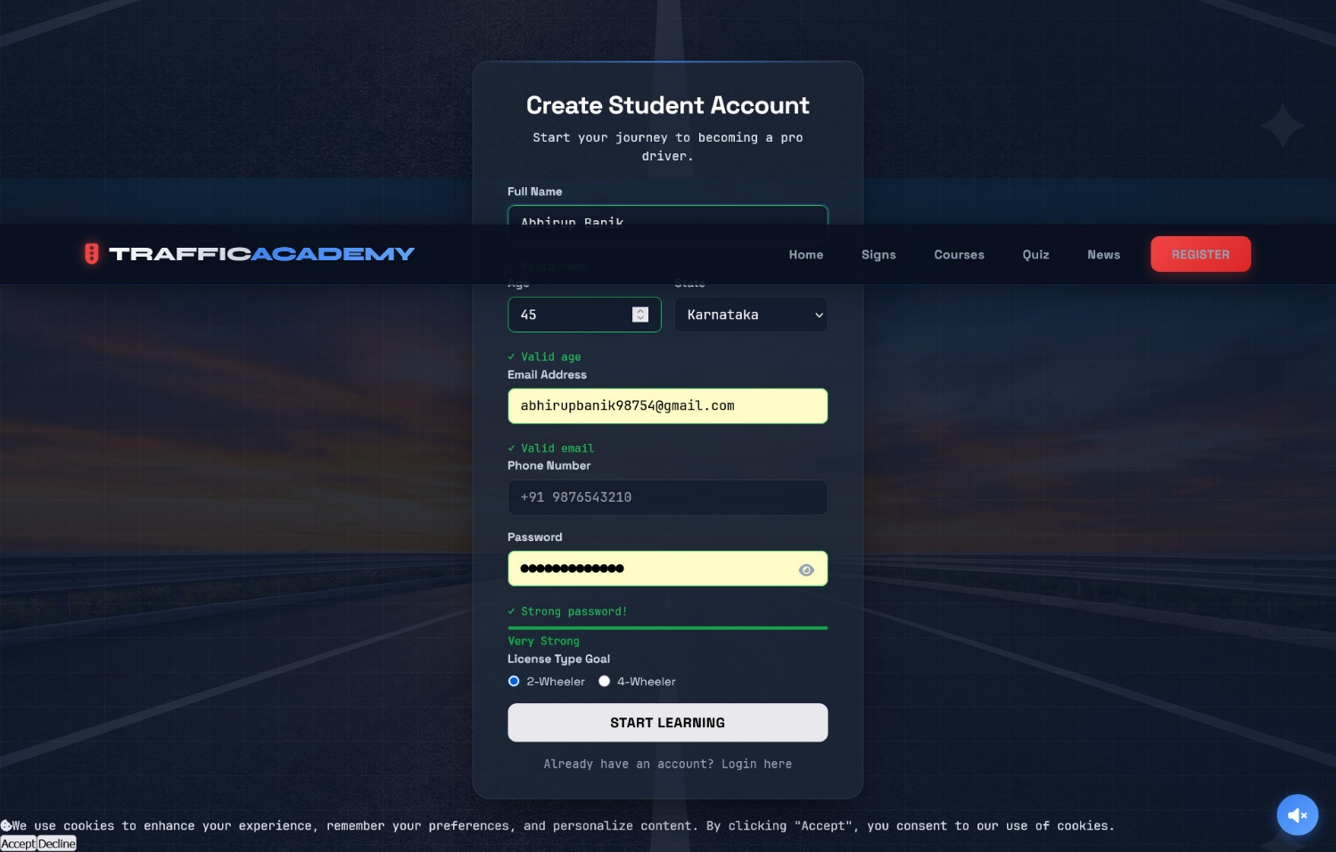

SIGNS PAGE

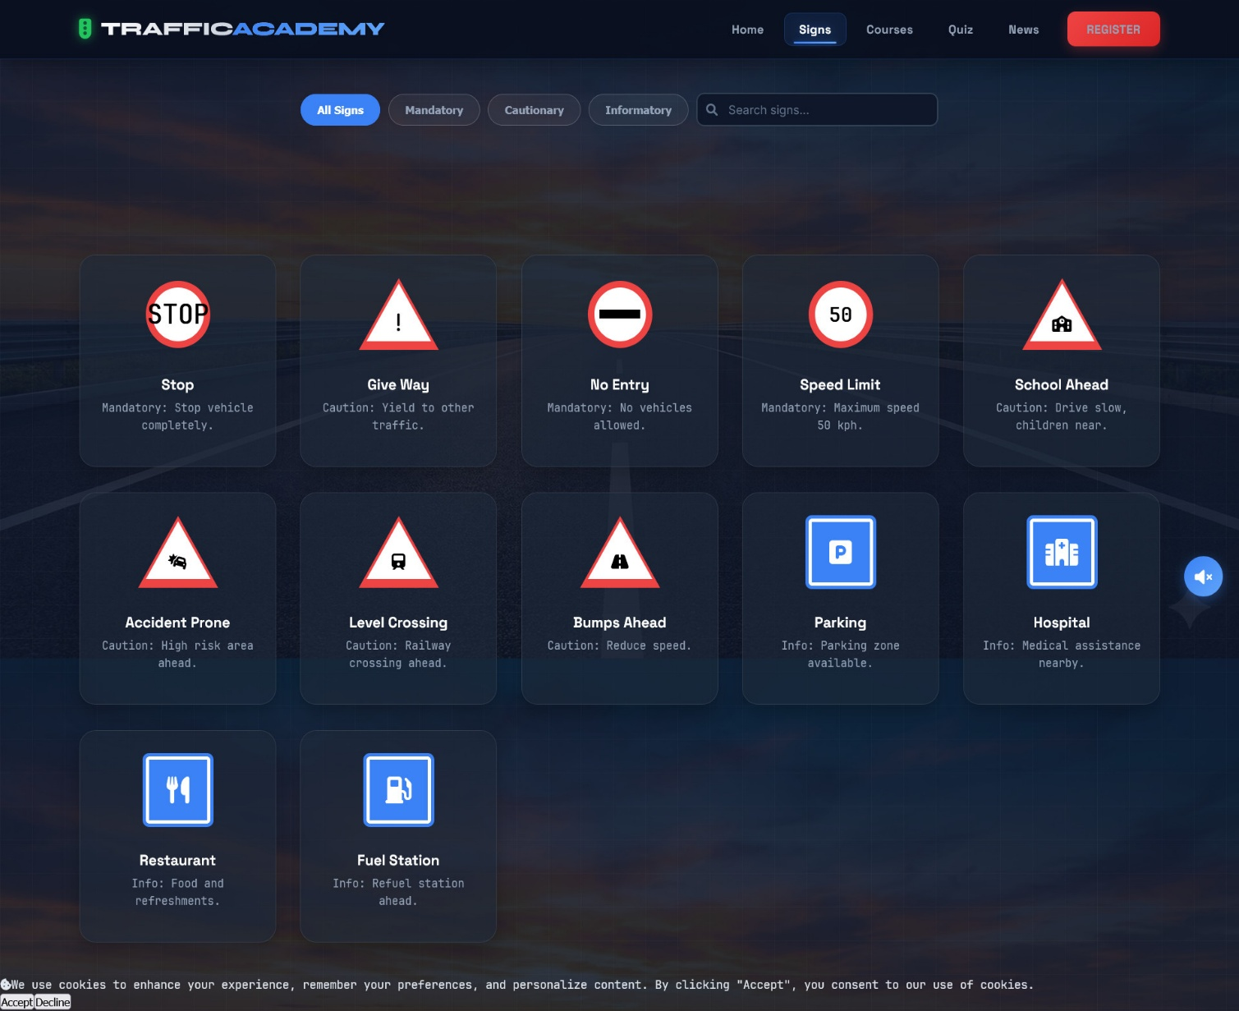

COURSE PAGE

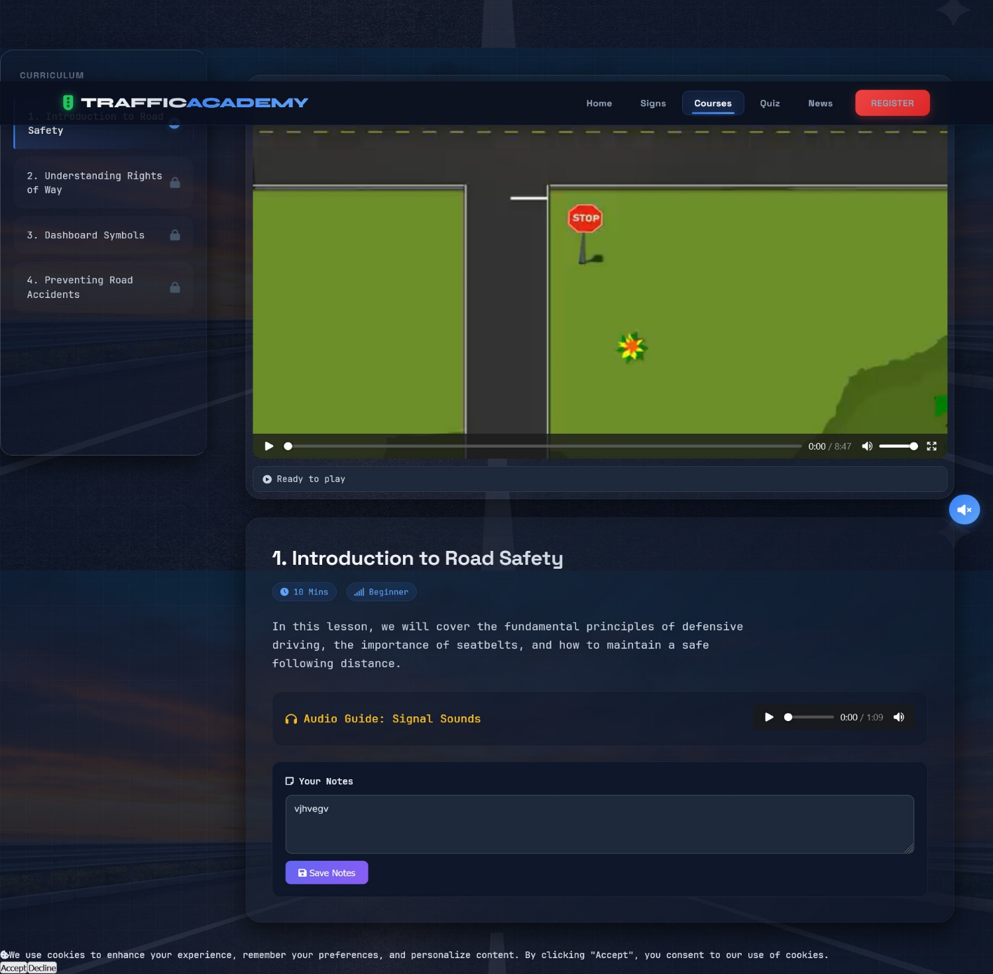

ASSESMENT PAGE
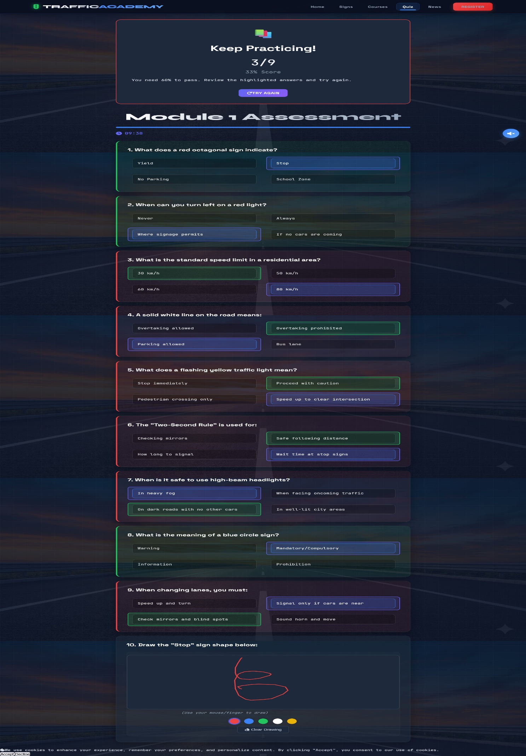

NEWS PAGE



EMERGENCY PAGE

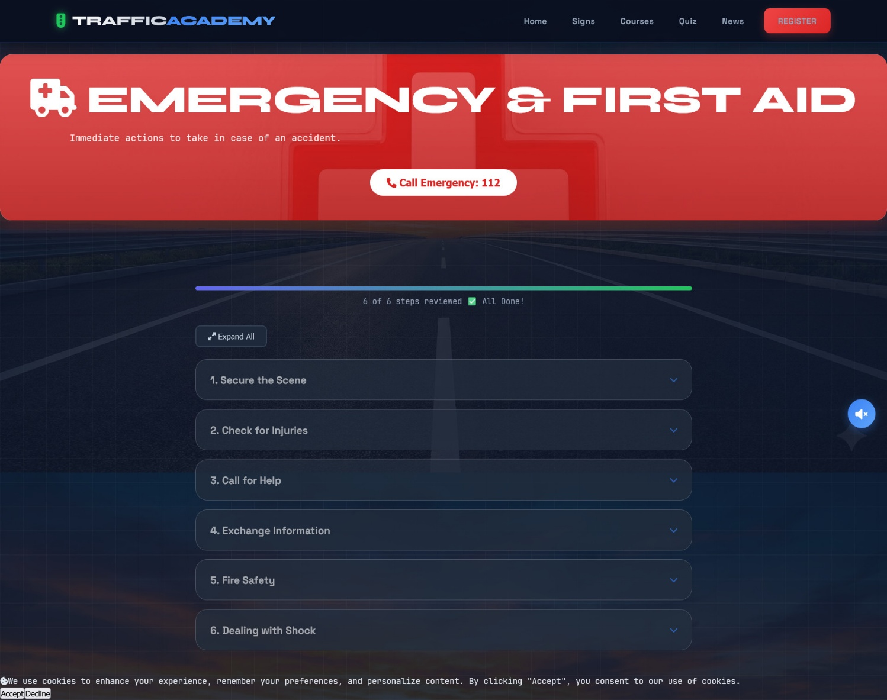

SUPPORT PAGE



CODE

GOOGLE DRIVE LINK-

https://drive.google.com/drive/folders/1P9TaHBomTUKdlAqj2MDiGDL3ShYCnvI5?usp=sharing

THANK
YOU

